National College of Ireland

PGDip in Cloud Computing

2011/2012

James Peyton - 10206515

Emily Maycock - 11207864

Brian Raymond - 10206248

Stephen O’Rourke - 11107065

Hotel Directory

Project in

Enterprise Frameworks



**Table of Contents**

Executive Summary 2

1. Introduction 3

2. 6

3. 13

4. Project Plan

5. Software Development Methodolgy

6.

7.

8.

9. Architectural Patterns 3

10. 6

11. 13

12.

13. Testing

14.

15.

16. Appendix A Team Project Management

**1. Introduction**

**blah blah**

**2. Background research and investigations**

The project specification requires us to develop a web application using C# and ASP.NET which exhibits the traits and qualities associated with an Enterprise level application. The first step was for us to decide on a theme for the application and create the project proposal. We decided on a ‘Hotel Review’ application that contains a database with Hotels from many city’s around the world and allows users to search these hotels and view reviews entered in the database. Users will also be able to enter personal reviews of hotels that they have visited and these will be added to the database. We had a steep learning curve to complete the project as none of our team members had any experience with the .NET Framework or C#. For this reason we chose to use MVC4 as this is what was used to create the in class demonstration project. We each followed the in class demonstration and also completed an MVC4 tutorial available on Microsoft’s ASP.NET website. We also used examples available at <http://www.codeproject.com> and <http://shrinkr.codeplex.com/> and used <http://stackoverflow.com> and <http://msdn.microsoft.com> to troubleshoot any issues we had.

We wanted to populate our database with data from a trusted open dataset and decided to use .csv file format. There are many sources of this type of data available and we choose http://nycopendata.socrata.com/ . We then used a csv validation tool available from http://sourceforge.net/projects/flatfi to ensure that the file was not corrupt and was structured correctly.

**3. Requirements analysis**

**4. Project Plan**

When the project was initially started each team member took it upon themselves to research the .Net framework and to gain an understanding of working with C# programming. The plan in place was for each member to have an attempt at all parts in the creation of the web application. All team members at some stage in the development of the application had problems using GitHub and had to continuously “clone” their folders on their local machines. Emily Maycock had continuous problems with GitHub which severely hampered her attempts to commit files.

Team members Emily and James looked at creating a database whilst team members Brian and Stephen set about creating the models and eventually the parser.

A breakdown of all the work completed to date is contained in the Appendix A.

**5. Software development methodology employed**

**Visual Studio**

The application was built in the Integrated Development Environment (IDE) Microsoft Visual Studio 2010. This environment provided all of the necessary tools for constructing each aspect of the application. It also automatically generates tests which ensure that each component functions correctly before it is fully implemented.

Microsoft’s object-oriented language, C#, was used to code the application.

**Agile Software Development**

Although not developing a full enterprise-level application, the team-based approach to the project meant that some of the aspects of agile software development were used.

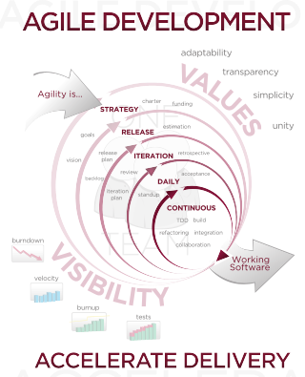

**Fig 5.1 Agile Development Diagram**

Some of the hallmarks of the agile approach include adaptive planning and evolutionary development and delivery. It also promotes rapid and flexible response to change. Throughout the development of the ‘Hotel Directory’, team members were responsible for different aspects of the system and flexibility was crucial as circumstances changed and goals were re-evaluated.

As of 2001, the ‘Agile Manifesto’ has been used as a set of guidelines for employing this approach to software development. Although this was not followed strictly during the development of the Hotel Directory, many of the principles were followed. For example:

* Individuals and Interactions – Interactions between team members and often programming in pairs to achieve goals or overcome obstacles
* Working software – A working version of the application was up and running quickly
* Responding to change – If one approach was not working, focus was switched to another method or idea. The application was scrapped and restarted at one point. This was necessary and allowed the project to progress.
* Simplicity – It was decided early on that application should cover the requirements of the project, but not become overly complicated.
* Face-to-face conversation – The most substantial progress was achieved when 2 or more team members collaborated.

**6. Use cases/Wireframes**

Wireframes :

Created using Balsamiq

Home page – this is the initial screen that is loaded when the application is built or when users click on the ‘Home’ link.

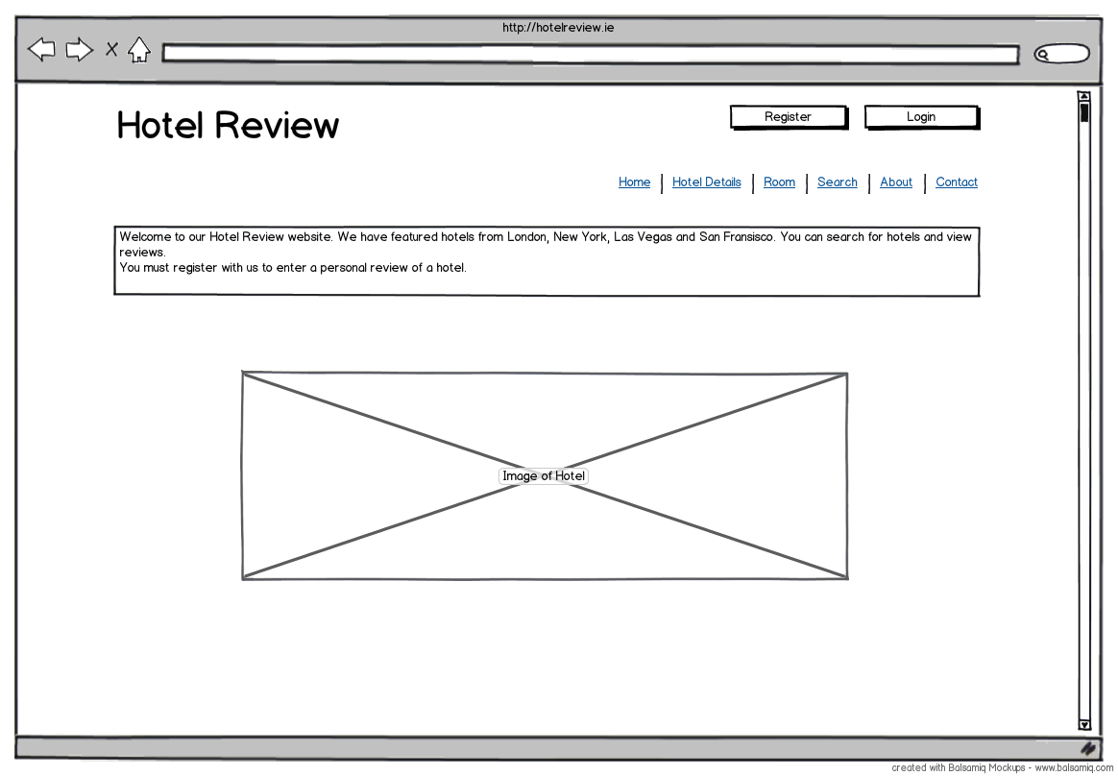

Hotel Details – this page is loaded by clicking on the ‘Hotel Details’ link

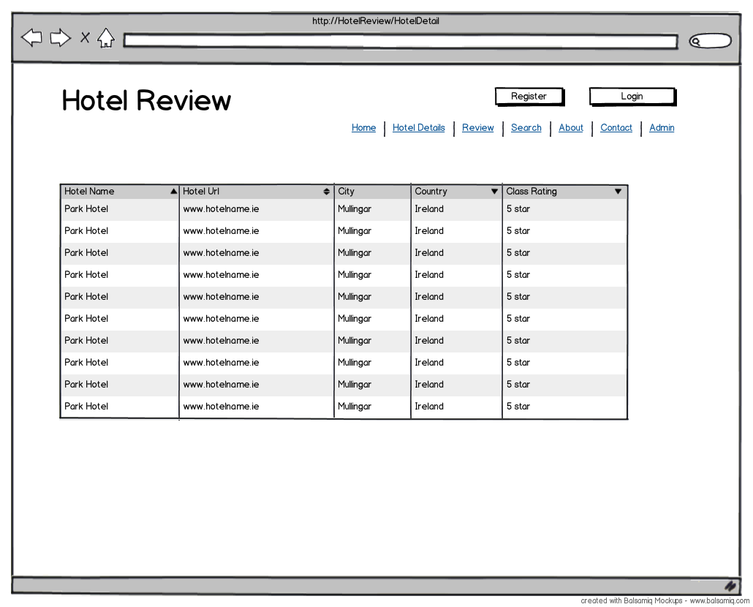

Search page – the search page wireframe below shows a portion of the Search Page and then the Search Results page that loads after users click the ‘Search’ button.

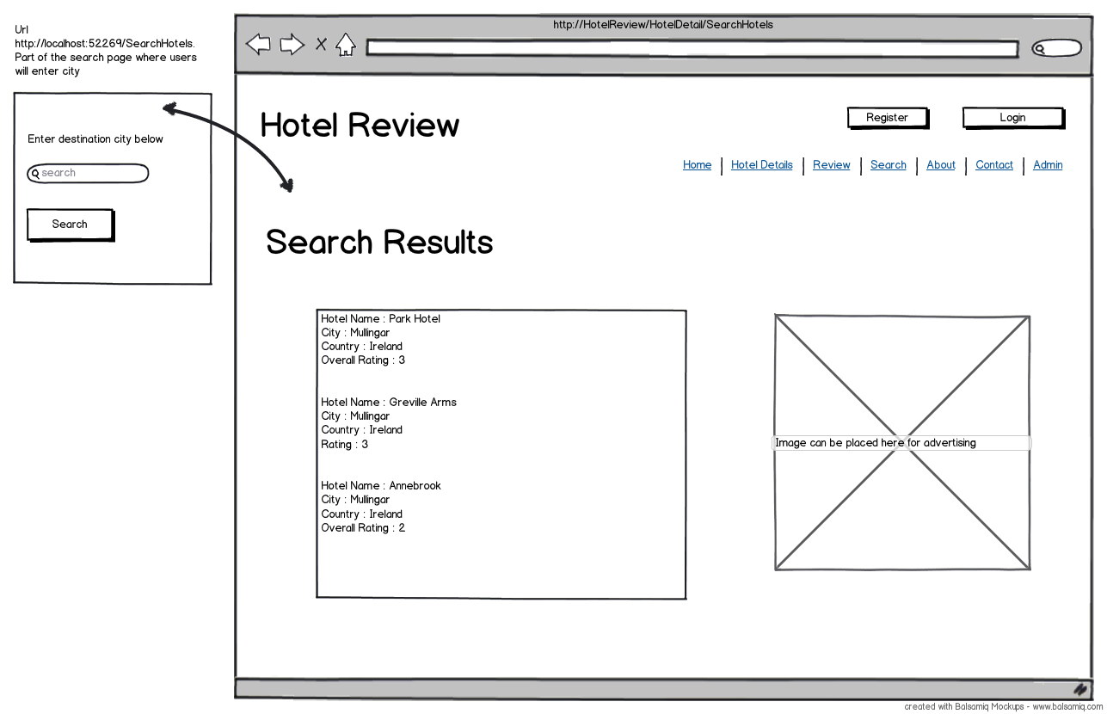

**7. Architecture/Design approach**

Models (Class Models / Data Models etc.)

**8. Implementation of particular OOP constructs**

Object oriented programming (OOP) is a programming paradigm using “objects” or data structures which consist of data fields and methods used together with their interactions to design applications. Unified Modelling language (UML) is used today as the standard for specifying, visualising, constructing and documenting the layout of software systems. A construct helps defines the relationship between UML models and accompanying implementation code in C# and this would include classes, interfaces, inheritance, Inversion of Control (IoC) and annotations. In OOP, classes are the actual containers for all of our coding.

**Classes**

In the Hotel Directory application a number of model classes are created which form the basis of the code first entity framework application. Each class created has attributes and behaviours and the behaviours are the actions that the class performs. In OOP, classes are the actual containers for all of our coding and these classes are held in another container called a package. Packages allow this application to logically group together to form the make-up of our Hotel Directory application.

**Interfaces**

An interface is sometimes referred to as a contract between two entities and using interfaces we can invoke functions from different classes through the same interface reference. The parser in the application is using an interface to communicate with the model to load the required CSV file.

**Inheritance**

Is the process describing the hierarchical relationship between classes and in (UML) inheritance is noted by a solid line with a closed arrow that points to a superclass. The relationship is called a generalisation. In the application the Data Access Layer or (DAL) layer inherits from the ingestion folder containing the CSV file.

**Inversion of Control (IoC)**

Inversion of Control (IoC) is a practice where the object coupling is bound at run time by an assembler object and is typically not known at compile time using static analysis. (IoC) is also a style of software construction where re useable code controls the execution of problem specific code. When implementing (IoC), containers are used to acquire instances of objects that would normally be created by the programmer. The Hotel directory is an enterprise application and using (IoC) improves flexibility and maintainability.

**Annotations**

In the .Net environment annotations are used for adding attributes to properties and nowhere is this more evident than in the model class. This application is created using Entity Frameworks and Code first data annotations. The System.ComponentModel.DataAnnotations namespace defines attributes that are used to provide additional information about classes and properties.

**9. Architectural Patterns**

**Domain Model**

There are a variety of approaches to architectural patterns in the business logic layer (BLL) of an enterprise application (e.g. Transaction script, table module, active record). The one that best covers the approach used here is the domain model. The aim is to insert a layer of objects that model the business area of the target application. This is relevant here as a model-first design was implemented in the project. The main model class was constructed first, to reflect the column headings in the hotel details csv file. Once the application was at a stage where the csv data could be imported to the database, this persistence was designated a dedicated, de-coupled data access layer (DAL). Therefore, the objects responsible for saving the hotel data are not concerned with the mechanics of the underlying database, where it is stored, etc.

An example of the business logic implemented in the application facilitates a search function, where results are retrieved from the database based on the city entered by the user. Due to use of the domain model, this business logic can in theory be re-used to perform other search types, or indeed the business logic can be used by other applications.

**MVC 4**

The principal architectural pattern employed with this application is MVC, which incorporates the Model, View and Controller. This allows for code reusability and ‘separation of concerns’.

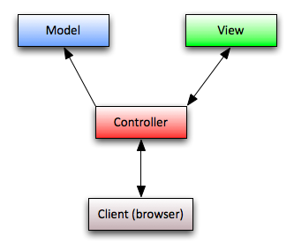

**Fig 9.1. Basic MVC structure**

There have been a few revisions of this architecture since its inception. The latest, MVC 4, which builds on top of the basic MVC structure, is used here. One of the core components introduced with MVC 4 is the ASP.NET Web API, which is well-suited to building REST-ful services. Features of the web API include:

* **Full support for routes:**Support for the full set of route capabilities of ASP.NET Routing.
* **Content negotiation:**Automatic support for XML, JSON, and Form URL-encoded formats.
* **Model binding and validation:**Model binders allow for simple data extraction from the different parts of an HTTP request. These parts are converted into .NET objects which can be used by the Web API actions.
* **Code-based configuration:**ASP.NET Web API configuration is achieved using code only. Other related setup files are created automatically
* **Improved support for Inversion of Control (IoC) containers:**Support provided for IoC containers.
* **Scaffolding:**Use the ‘Add Controller’ dialog to quickly scaffold a web API controller. This is based on an ‘Entity Framework’ based model type.

**5 layers implemented**

The ‘Hotel Directory’ web application has been built upon the 5 layers of a layered architecture system, as follows:

* User Interface/Client – HTML pages containing data generated by the Hotel Directory, and to accept input from the user.
* Presentation Layer – Accepts input from the view and passes the data to the business logic layer.
* Business Logic Layer – Extrapolates data from the DAL and formats it to suit the business requirements of the application.
* Data Access Layer – Performs 2 main functions.

1. Persists hotel information from csv sources into the database. If the database already contains data, the import routine aborts.
2. Retrieves data back for eventual presentation to the user (after filtering through higher layers).

* Database – SQL server DB which retains hotel information obtained from open data sources over the web.

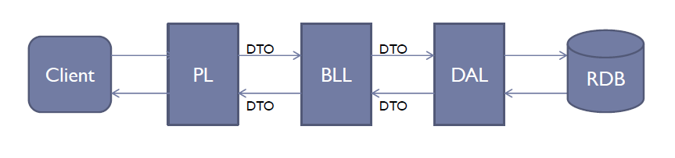

**Fig 9.2. Five layers**

**Cross-cutting concerns**

If any member of the team needed to work on a specific area of the application (e.g. DAL, Models) they would notify the rest of the team prior to making the change. This was seldom an issue, as the project plan indicates that team members usually carried out work on separate components.

**10. Security of the application**

**11. Configuration of the application**

**12. Scalability of the application**

**13. Testing Approach**

**Unit testing**

This approach is central to the concept of test-driven development. The idea being that a type of test harness is constructed for each class to make sure it functions properly before being implemented in the project.

A number of unit tests were created to this end within Hotel Directory, using assertions to verify whether the specified conditions are met.

London CSV parser unit tests

There are 2 main methods used in the ‘londoncsvparser’ class, parseHotelDetails() and supportsType(), which accepts a ‘format’ parameter.

* parseHotelDetails() creates a connection to the csv file:

StreamReader reader = new StreamReader("C:\\london.csv", true);

Next, 2 lists of ‘HotelDetail’ objects are created, one for the expected number of lines in the file, and the second to represent the actual number of lines found.

The assertion raised is to check that the expected and actual values match:

Assert.AreEqual(expected.Count, actual.Count);

* supportsType() creates an IDataParser and assigns to an instance of the londoncsvparser class:

IDataParser target = new londoncsvparser();

2 boolean variables are created for use in the test’s assertion that the expected file format and expected file format match:

Assert.AreEqual(expected, actual);

Functional testing (errors encountered, etc)

**References**

ASP.NET MVC 4 : Official Microsoft Site. 2012. ASP.NET MVC 4 : Official Microsoft Site. [ONLINE] Available at: <http://www.asp.net/whitepapers/mvc4-release-notes>. [Accessed 24 July 2012].

Agile software development - Wikipedia, the free encyclopedia. 2012. Agile software development - Wikipedia, the free encyclopedia. [ONLINE] Available at: <http://en.wikipedia.org/wiki/Agile_software_development>. [Accessed 24 July 2012].

Object Oriented Programming. 2012. Object Oriented Programming. [ONLINE] Available at: http://tonyfear.netau.net/index.php?option=com_content&view=article&id=124:object-oriented-programming&catid=3:c-category&Itemid=5. [Accessed 25 July 2012].

Code First Data Annotations . 2012. Code First Data Annotations . [ONLINE] Available at: <http://msdn.microsoft.com/en-us/library/gg197525%28v=vs.103%29.aspx>. [Accessed 28 July 2012].

**16. Appendix A - Team Project Management**

|  |  |  |  |  |
| --- | --- | --- | --- | --- |
| Team Jebs | | | |  |
| To-do List | | | |  |
|  |  |  |  |  |
| **Task No.** | **Task** | **By** | **% Complete** | **Date** |
| **A** | **Documentation** |  |  |  |
| 1 | Proposal |  |  |  |
| 2 | Design Use cases | EM | 50% |  |
| 3 | Final Project Report | All | 5% |  |
| 4 | Update main document with use cases | EM | 0% |  |
| 5 | Use Cases created | EM | 100% | 11/7/2012 |
| 6 | Git problems resolved update | JP | 100% | 11/7/2012 |
| 7 | Use Cases | EM | 100% | 13/7/2012 |
| 8 | MVC3 Design Pattern | JP | 100% | 17/7/2012 |
| 9 |  |  |  |  |
| 10 |  |  |  |  |
| **B** | **General** |  |  |  |
| 1 | Install MVC 4 | All | 100% | 10/06/2012 |
| 2 | Create MVC4 Project and upload to Git | EM | 100% | 14/06/2012 |
| 3 | Data Sets Added | BR | 75% | 19/6/2012 |
| 4 | Data Sets Added | BR | 85% | 4/7/2012 |
| 5 | New project created | SOR | 100% | 7/7/2012 |
| 6 | Database Created | BR | 75% | 10/7/2012 |
| 7 | Home Page update | SOR | 100% | 15/7/2012 |
| 8 | Data Set Added | JP | 100% | 16/7/2012 |
| 9 | Database tables updated | JP | 100% | 16/7/2012 |
| 10 | References Added | JP | 100% | 21/7/2012 |
| 11 |  |  |  |  |
| 12 |  |  |  |  |
| 13 |  |  |  |  |
| 14 |  |  |  |  |
| 15 |  |  |  |  |
| **C** | **Data Modelling/Parser** |  |  |  |
| 1 | Model Attempt | BR | 100% | 17/6/2012 |
| 2 | Model Attempt | SOR | 100% | 24/6/2012 |
| 3 | IData Parser | SOR | 100% | 3/7/2012 |
| 4 | Parser London | SOR | 100% | 3/7/2012 |
| 5 | Parser New York | BR | 100% | 3/7/2012 |
| 6 | Model DB Attempt | SOR | 100% | 7/7/2012 |
| 7 | Parser Las Vegas | JP | 100% | 16/7/2012 |
| 8 | Parser Load | BR | 85% | 17/7/2012 |
| 9 | CSV Parser | JP | 100% | 21/7/2012 |
| 10 |  |  |  |  |
| 11 |  |  |  |  |
| 12 |  |  |  |  |
| 13 |  |  |  |  |
| 14 |  |  |  |  |
| 15 |  |  |  |  |
| **D** | **DAL/Business Logic** |  |  |  |
| 1 | DAL Layer created | SOR | 20% | 10/7/2012 |
| 2 | DAL Layer updated | EM | 100% | 23/7/2012 |
| 3 |  |  |  |  |
| 4 |  |  |  |  |
| 5 |  |  |  |  |
| 6 |  |  |  |  |
| 7 |  |  |  |  |
| 8 |  |  |  |  |
| 9 |  |  |  |  |
| 10 |  |  |  |  |
| **E** | **MVC** |  |  |  |
| 1 | Controllers & Views created | BR | 100% | 17/7/2012 |
| 2 |  |  |  |  |
| 3 |  |  |  |  |
| 4 |  |  |  |  |
| 5 |  |  |  |  |
| 6 |  |  |  |  |
| 7 |  |  |  |  |
| 8 |  |  |  |  |
| 9 |  |  |  |  |
| 10 |  |  |  |  |
| **E** | **Test Driven Development** |  |  |  |
| 1 | Test class London Parser | SOR | 100% | 10/7/2012 |
| 2 | New Test Methods | SOR | 100% | 17/7/2012 |
| 3 |  |  |  |  |
| 4 |  |  |  |  |
| 5 |  |  |  |  |
| 6 |  |  |  |  |
| 7 |  |  |  |  |
| 8 |  |  |  |  |
| 9 |  |  |  |  |
| 10 |  |  |  |  |